**Create your first Firehose stream**

Now that all the pieces are in place, you're ready to create your first Firehose delivery stream. This will set you up for being able to send data to the stream, and the stream will put it into the S3 bucket.

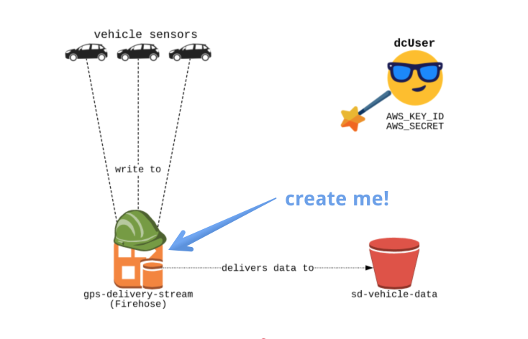

**Setup** Notice a file _setup.py; In this file, we will create the boto3 clients for firehose and s3. You don't need to edit this file for exercises, but you're more than welcome to read it!

**File to edit**

You will be editing the create_firehose.py file in the editor.

**Destination S3 Bucket**

You will create an "sd-vehicle-data" S3 bucket to be used as the destination for our stream.

**Role**

The role we have created is "fireHoseDeliveryRole" with an ARN of: "arn:aws:iam::0000000:role/firehoseDeliveryRole".

This role will allow our new Firehose stream to write to the "sd-vehicle-data" bucket.

**Slides**

Don't forget - you can always click on the **slides** icon in the top right to see the slides - they'll be pretty helpful!

**Instructions**

**100XP**

* Create the firehose delivery stream, "gps-delivery-stream", with "sd-vehicle-data" bucket as destination.
* The stream should assume (or use the hat of) "firehoseDeliveryRole" when writing to this bucket.
* Print the ARN of the Firehose stream you have created.
* Execute create_firehose.py by running python3 create_firehose.py in the terminal. Then, click the "Submit Answer" button below.

Code:

# create_firehose.py: Create firehose stream. No need to edit.

import _setup

firehose, s3 = _setup.ex_vars

# Create s3 bucket

s3.create_bucket(Bucket='sd-vehicle-data')

# Create Firehose delivery stream

res = firehose.create_delivery_stream(

DeliveryStreamName ="gps-delivery-stream",

DeliveryStreamType ="DirectPut",

# Specify configuration of the destination S3 bucket

S3DestinationConfiguration = {

"BucketARN": "arn:aws:s3:::sd-vehicle-data",

"RoleARN": "arn:aws:iam::0000000:role/firehoseDeliveryRole"

})

# Print the stream ARN

print("Created Firehose Stream ARN: {}".format(res['DeliveryStreamARN']))

Output:

Created Firehose Stream ARN: arn:aws:firehose:us-east-1:000000000000:deliverystream/gps-delivery-stream